**Project Report**

College Admission Management

System



**SUBMITTED TO SAVITRIBAI PHULE PUNE UNIVERSITY**

**SUBMITED BY**

**Students Name: Sakshi Sunil Korde ROLL NO: 056**

**Students Name: Roshan Pramod Muneshwar ROLL NO: 102**

**UNDER THE GUIDANCE OF**

**Kalyani Alisethy Mam**

**In Partial Fulfillment of MASTERS IN COMPUTER APPLICATION**

**SINHGAD INSTITUTE OF BUSINESS ADMINISTRATION AND RESEARCH**

**KONDHWA, PUNE-411048 2022-2023**

**CERTIFICATE OF ORIGINALITY**

This is to certify that the project report entitled **College Admission Management System.**

Submitted to the Department of Computer Applications, Sinhgad Institute of Business Administration and Research in partial fulfillment of the requirement For the award of the degree of MASTER OF COMPUTER APPLICATIONS (MCA

Affiliated to Savitribai Phule Pune University), is an original work carried out by Sakshi Sunil Korde (56), Roshan Pramod Muneshwar (102)

The matter embodied in this project is a genuine work done by the student and has not been submitted whether to this Organization or to any other University/ Organization for the fulfillment of the requirement of any course of study.

Signature of the Student

:

Name of the student

: Sakshi Sunil Korde

Signature of the Student

:

Name of the student

: Roshan Pramod Muneshwar

Name and Designation of the Guide

: Prof. Kalyani Alisetty

Signature of Director-MCA

(Dr. Netra Patil)

Date

:

:

**CERTIFICATE OF APPROVAL**

This is to certify that the project report entitled “**College Admission Management System.**”

submitted to the Department of Computer Application**, Sinhgad Institute of Business Administration and Research** in partial fulfillment of the requirementfor

the award of the Degree of **MASTER OF COMPUTER APPLICATIONS**

**(MCA Affiliated to Savitribai Phule Pune University)** is an original work carried out

by Ms. Sakshi Sunil Korde (56), Mr. Roshan Pramod Muneshwar (102)

The matter embodied in this project is a genuine work done by the student and has

been certified by the following internal and external examiners deputed by

**Savitribai**

**Phule Pune University.**

Internal Examiner External

Examiner

**ACKNOWLEDGEMENT**

We are pleased to acknowledge **Kalyani Alisethy Mam** for their invaluable guidance during the course of this project work. As our project COLLEGE ADMISSION MANAGEMENT SYSTEM which envelops the automation of all work. We have tried our level best to make our project as simple possible.

We would also like to give special thanks to all the talented personalities of our institute who had given us a moral support completing our visual basic project.

# CONTENTS

**Introduction**

**Problem specification Background and related work Goals**

**Hardware Requirements**

**Software Requirements**

**Proposed System**

**Product Overview**

**Feasibility study**

**Flow chart**

**ER Diagram**

**Data Flow Diagram Database and MySQL Tables Output screen**

**System Testing**

**Design and implementation constraints Supplementary requirements**

**Other nonfunctional requirement Conclusion**

**Reference**

**INTRODUCTION**

Today all the work at the time of admission of the students is done manually by ink and paper, which is very slow and consuming much efforts and time. In the modern world of technology, computer are affecting our lives in more ways than we probably are aware of COMPUTERIZED MANAGEMENT maintaining information of an educational institute, colleges, other the list is endless. The main principle behind the need of college admission system is easy supervision of institutes. It can handle the details of students such as personal details or admission details. This Student Database has been designed taking into account the practical needs to manage a Students data. Moreover, it provides security at product level as well as user level. Its design concentrates on 2 types of users:

1. Admin
2. Students

# PROBLEM SPECIFICATION

Student admissions are a vital part of any College’s running because students are what keep a College alive. The student admission is one of the most important activities within a College as one cannot survive without students. A poor admissions system can mean fewer students being admitted into a College because of mistakes or an overly slow response time. The process begins with a potential student completing an application form through the Universities and Colleges Admissions Service, the first step for students is to apply directly to the College through a custom online form. The next step is for the Admissions service center has to review the application and ensure that all of the required information has been provided. The application in its entirety is then forwarded, complete with a recommendation, to the respective department’s Admissions Tutor, who has the final say as to whether each potential student is Accepted or rejected. Before making a decision, the Admissions Tutor reviews the application and the additional documentation, comparing the academic credentials to a list of College rankings and previous, similar applications.

# BACKGROUND AND RELATED WORK

The main aim of our project is to develop the application which will be useful in college admission system. As this college admission system project includes the admission process of student, starting from when the student takes admission in college in first year till that submission of examination form from the college. The requirement of the student is to:

 User can contact with administrative by sending mails.  User can view about us and contact us page.

 User can view notices which is published by admin.  User can view courses which are listed by admin.

 User can register himself.

 After registration user can login into system and apply for admission.

 After successful submission of admission form application will pop up in admin panel for review.

 If application is selected user can submit their fees.  User can update their profile details

 Change his / her own password.

 Admin login should be present who can read as well as view any uploads.  Admin can select and reject any application.

 Admin can manage (add/update) the course.  Admin can manage public notice.

 Admin can mange users (Students) enquiry.

 Admin can search application by application number.

 Admin can manage enquiry which is received by students.  Admin can view subscriber mail.

 Admin can generate reports of application.

The student details in separate records are tedious task. Referring to all these records and updating is needed. Since the number of students are growing and management has to handle records of all of the students, it is facing the little bit problems in Maintaining the records of students.

# GOALS

The main goal of the system is to automate the process carried out in the organization with improved performance and realize the vision of paperless admission. Some of the goals of the system are listed below:

 Manage large number of student details.

 Manage all details of student who registered for the course and send appropriate details about the course to the students account.

 Create student accounts and maintain the data’s effectively.

 View all the details of the students.  Create the statistical reports.

 Reduce the work load in interview the students for selection and Counseling should be very effective rather than direct methods.

# HARDWARE REQUIRMENT

CPU : Intel i3

RAM : 1 GB

HDD : 1 TB

MOITOR : V.G.A, LCD, LED

Keyboard, Mouse, Printer.

# SOFTWARE REQUIRMENT

Database Server : MySQL

Web Server : Apache

Frontend : HTML, CSS, Bootstrap, Scripting language : Java Script

IDE : Visual Studio Code

Backend : PHP

# PROPOSED SYSTEM

* + It is automated computerized web based software system.
  + It uses technologies like PHP, HTML, and MYSQL.
  + It is easy to operate.
  + Attractive User Interface.
  + Manage large number of student details.
  + Manage all details of student who registered for the course
  + Create student accounts and maintain the data’s effectively.
  + View all the details of the students.
  + Reduce the work load in interview the students for selection
  + Activities like updating, modification, deletion of records should be easier.

# PRODUCT OVERVIEW

Overall Description will describe major components of the system, interconnection and external interfaces.

Specific Requirements will describe the functions of actors, their role in the system and constraints.

##### Overall Description:

The rest of this document will give further details on the overall product description, including the hardware, software, and communications interfaces, product functions, user characteristics, and any assumptions that will be made.

##### Specific Requirements:

The college will also include the specific requirements needed. These will include the functions, performance, design, and software attributes. This document is organized in a logical manner and is easy to follow. Readers should refer to the table of contents, appendices, or index if looking for something in specific. Otherwise, reading this document from start to finish will start with a vague description and get more specific and detailed as changing sections an

**FEASBILITY STUDY**

A feasibility study is undertaken to determine the possibility of either improving the existing system or developing a completely new system. This study helps to obtain an overview of the problem and to get rough assessment of whether feasible solutions exist. Since the feasibility study may lead to the commitment of large resources, it is important that it is conducted completely and that no functional errors of judgements are made.

The purpose of feasibility study is to determine whether the requested project is successfully relizable. There are three aspects of feasibility study ,namely

* + - Technical feasibility
    - Economic feasibility
    - Operational feasibility

# FLOW CHART

**User flow chart**

**CAMS**

**User Signup**

**After Signup Login**

**Apply for admission**

**Submit**

**Admin Flow Chart**

**CAMS**

**Login**

**Admission application Selected Rejected**

**View All User Info And**

**View the admission Application**

**Use Case flow Diagram (User)**

Visit website

View Courses

Send Enquiry

Signup

Login

**User**

User Dashboard

Apply for Admission

Application

Selected Application

Submit fees

Change Password

Update Profile

**Use Case flow Diagram (admin)**

Login

Admin Dashboard

View user details / View Application/Subscriber

Select / Reject Admission Applications

**Admin**

Search Application by Name / Email / Contact number

Create and Manage Courses

Publish and Manage public notice

Manage Enquiry

Manage Pages

Generate Report

Update Profile

Change Password

**E-R DIAGRAM**

E-R (Entity-Relationship) Diagram is used to represents the relationship between entities in the table.

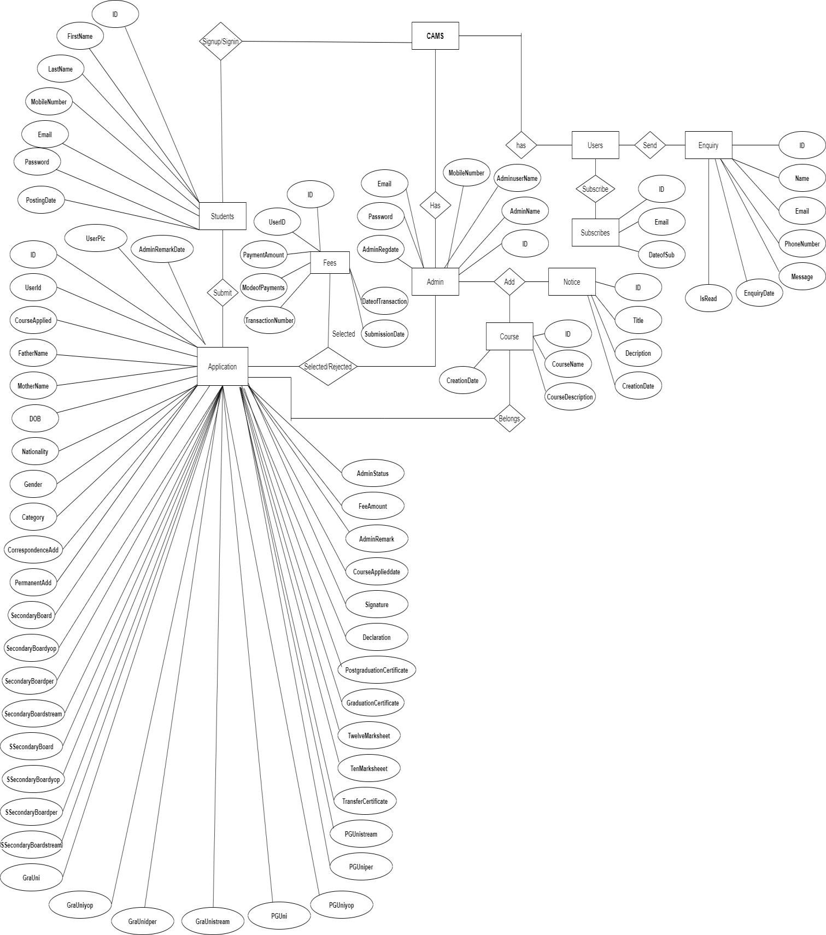

**Data Flow Diagram**

**Zero Level DFD**

**CAMS**

Course Management

Enquiry Management

Subscriber Management

Students Management

Pages Management

Admission Management

Notice Management

**1st Level DFD**

Admission Management

**CAMS**

Check Subscribers

Check Pages

Check Notices

Check Course Details

Generate Application

Students Management

Course Management

Users Enquiry Management

Notice Management

Page Management

Search Applications

Registration

Forgot

Password

**Users**

**2nd Level**

**DFD**

Login to

system

Check roles

of access

Check

Credentials

Manage

Modules

Manage Pages

Manage

Subscriber

Change Profile

Change Password

Generate Report

Manage Enquiry

Manage Notice

Manage Course

Manage Application

Manage Registered Users

Forgot

Password

Send

email to users

**Admin**

Login to

system

Check roles

of access

Check

Credentials

Manage

Modules

Change Password

Change Profile

Submit Fees

Subscribe

Send Enquiry

Submit

**Admin Activity Diagram**

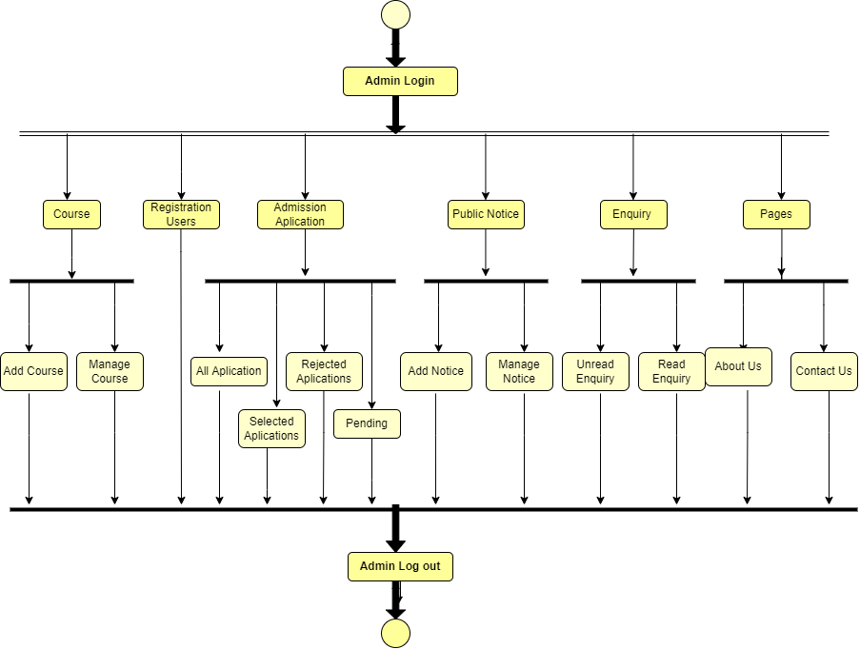

**User Activity Diagram**

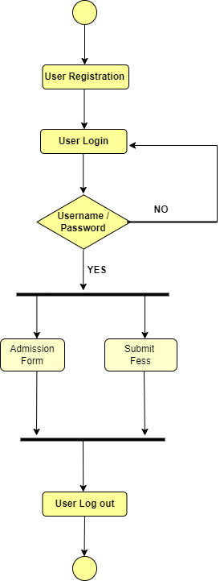

**Database and MySQL Tables**

MYSQL- MySQL ("My S-Q-L", officially, but also called "My Sequel") is (as of July 2013) the world's second most widely used open-source relational database management system (RDBMS). It is named after co-founder Michael Widenius daughter, My. The SQL phrase stands for Structured Query Language. The MySQL development project has made its source code available under the terms of the GNU General Public License, as well as under a variety of proprietary agreements. MySQL was owned and sponsored by a single for-profit firm, the Swedish company MySQL AB, now owned by Oracle Corporation .MySQL is a popular choice of database for use in web applications, and is a central component of the widely used LAMP opens source web application software stack (and other 'AMP' stacks). LAMP is an acronym for "Linux, Apache, MySQL, Perl/PHP/Python." Free-software-open source projects that require a full-featured database management system often use MySQL. For commercial use, several paid editions are available, and offer additional functionality. Applications which use MySQL databases Library Management System include: TYPO3, MODx, Joomla, WordPress, phpBB, MyBB, Drupal and other software. MySQL is also used in many high- profile, large-scale websites, including Wikipedia, Google (though not for searches), Facebook, Twitter, Flickr, and YouTube.

**Database tables**

In this project various tables used for maintain the information.

[**tbladmin**](http://localhost/phpmyadmin/sql.php?db=camsdb&token=0cdfa1f46252d35aec9fa851dd4c03bb&goto=db_structure.php&table=tbladmin&pos=0)

This table stores the login details of admin.

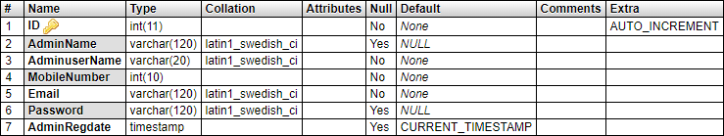

[**tbluser**](http://localhost/phpmyadmin/sql.php?db=camsdb&token=0cdfa1f46252d35aec9fa851dd4c03bb&goto=db_structure.php&table=tbluser&pos=0)

This table stores the details of registered users.

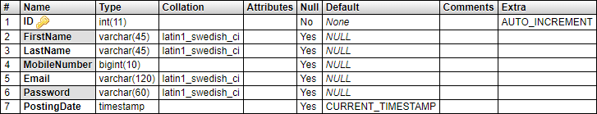

[tblcourse](http://localhost/phpmyadmin/sql.php?db=camsdb&token=0cdfa1f46252d35aec9fa851dd4c03bb&goto=db_structure.php&table=tblcourse&pos=0)

This table store the details of course which is provided by college.

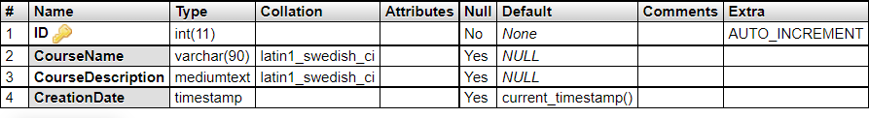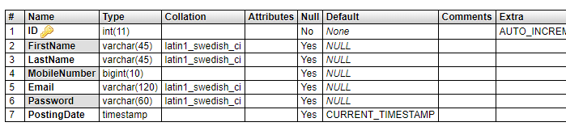

[**tblnotice**](http://localhost/phpmyadmin/sql.php?db=camsdb&token=0cdfa1f46252d35aec9fa851dd4c03bb&goto=db_structure.php&table=tblnotice&pos=0)

This table store the details of notice which is generated by admin

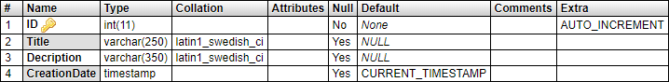

[**tbladmapplications**](http://localhost/phpmyadmin/sql.php?db=camsdb&token=0cdfa1f46252d35aec9fa851dd4c03bb&goto=db_structure.php&table=tbladmapplications&pos=0)

This table stores the application details which is received by students.

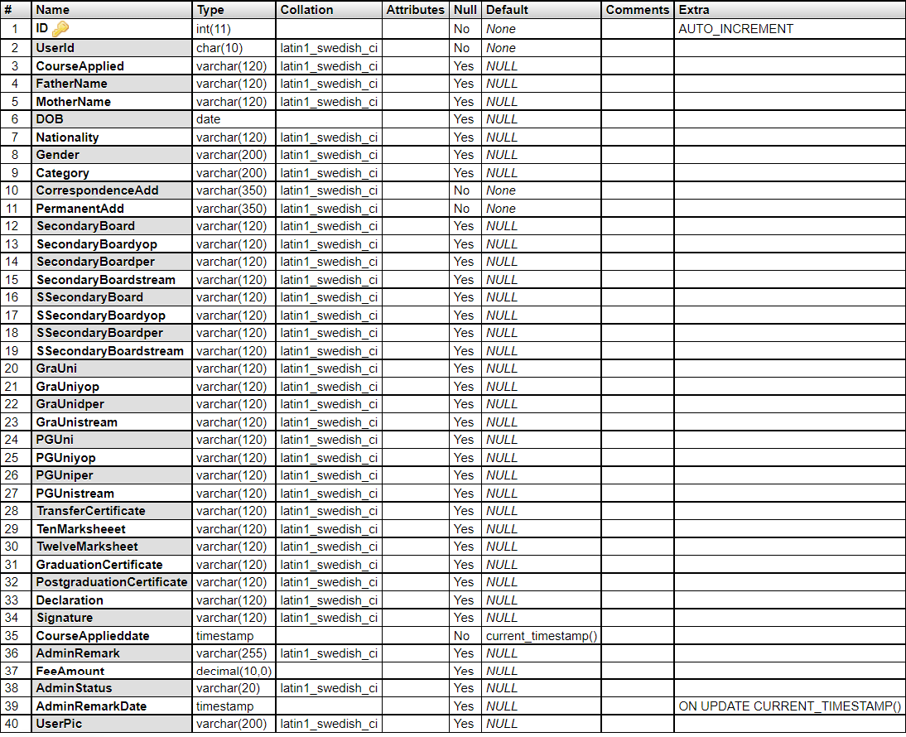

tblcontact

This table store the data of enquiry which is send by users.

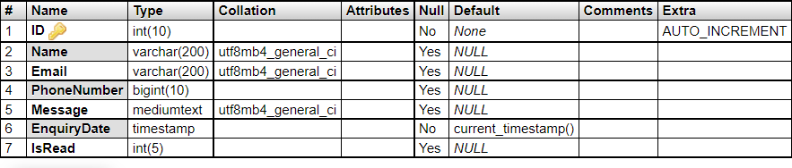

tblpage

This table store the data of about us and contact us.

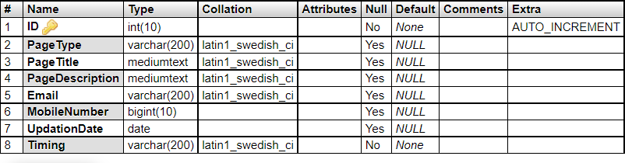

tblsubscriber

This table stores the emails id of subscribers.

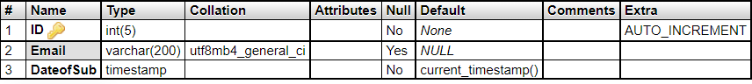

**Database Tables Relation**

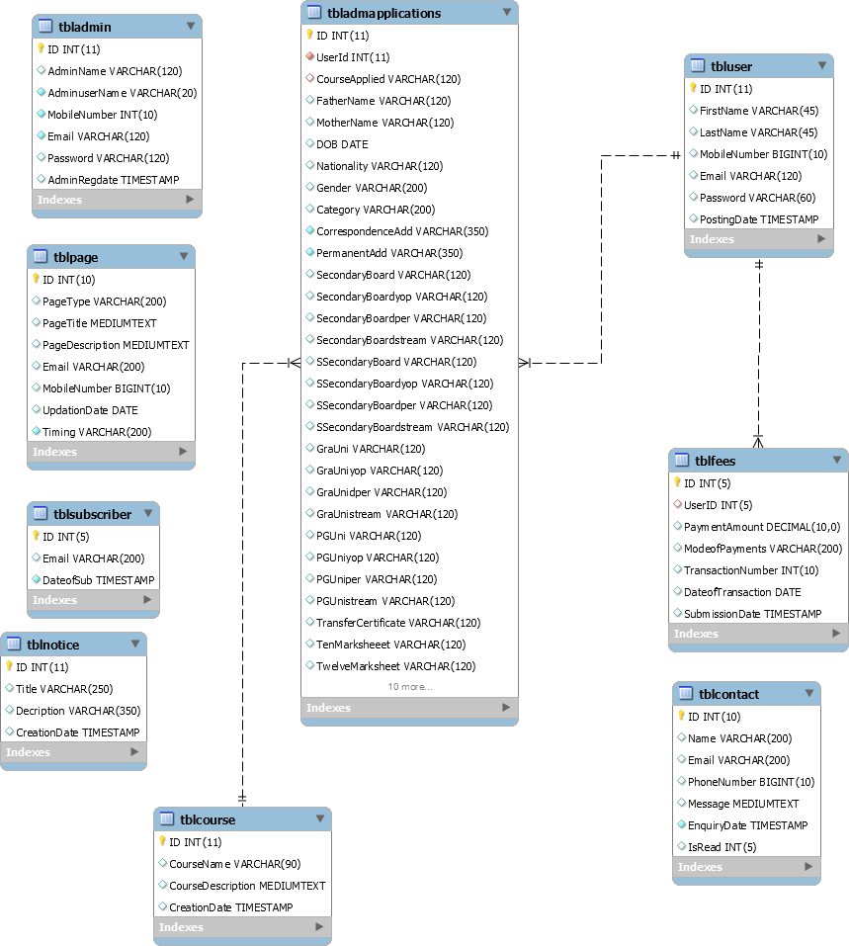

**Home Page**

**Output SCREENS**

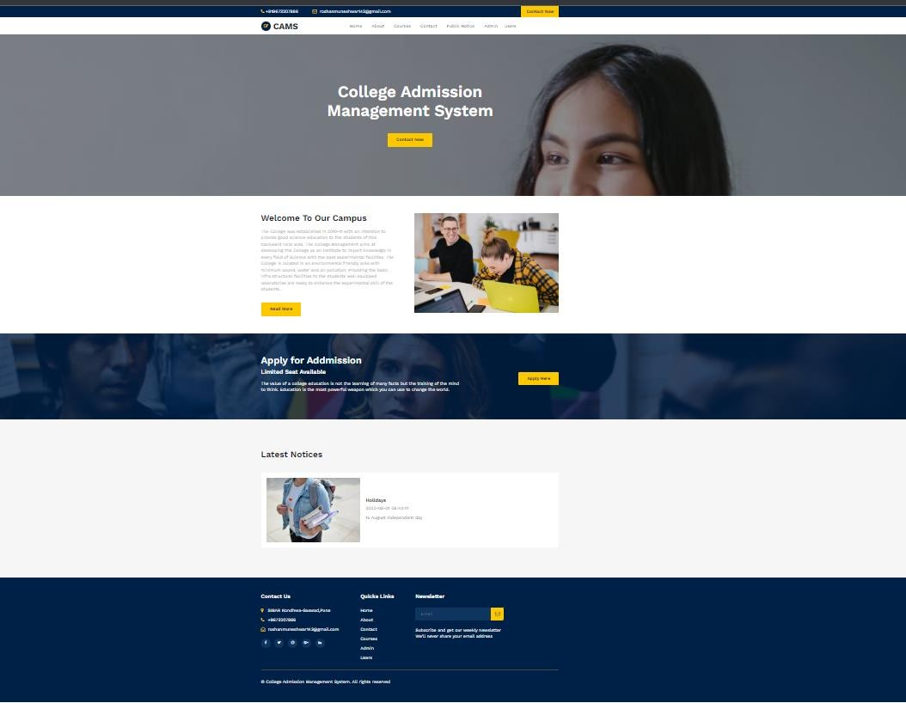

**About Us**

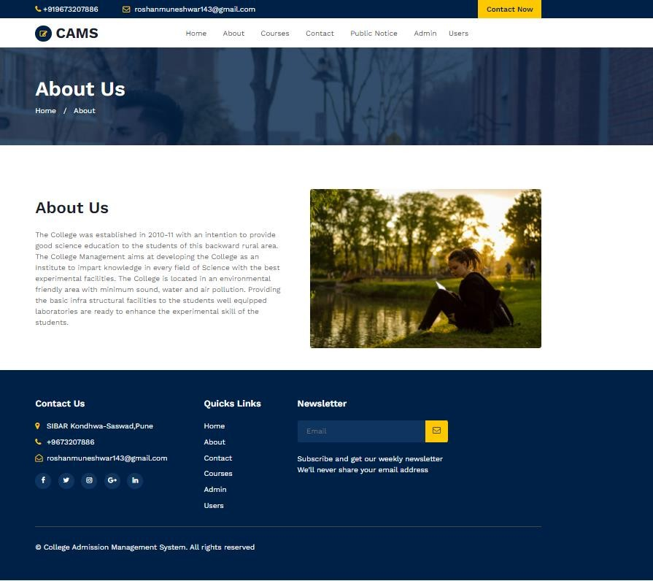

**Contact Us**

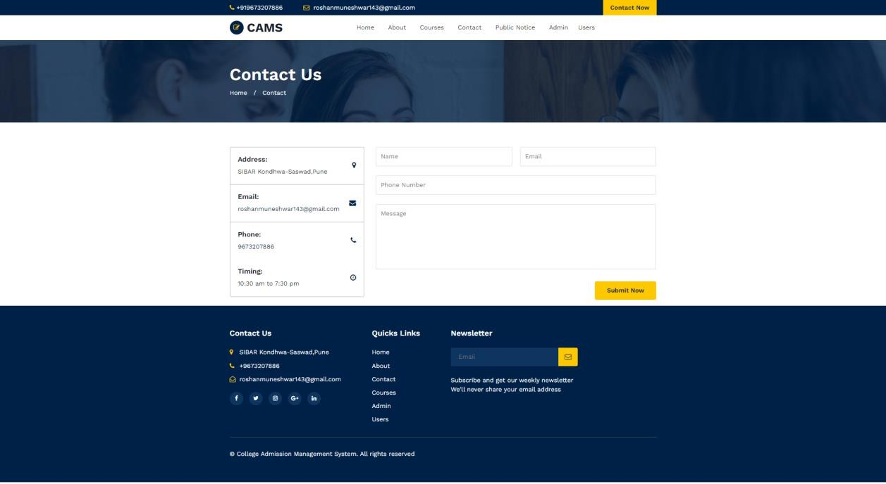

**Courses**

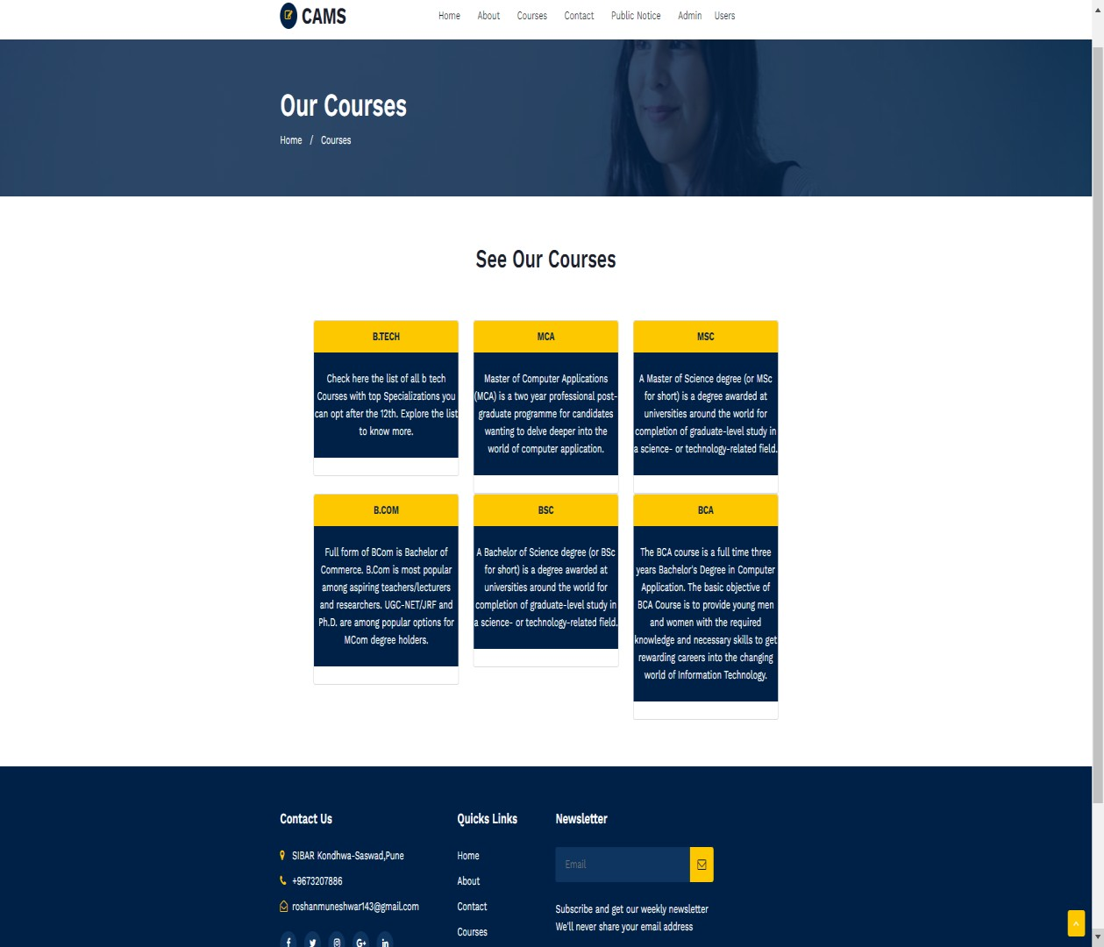

**Notice**

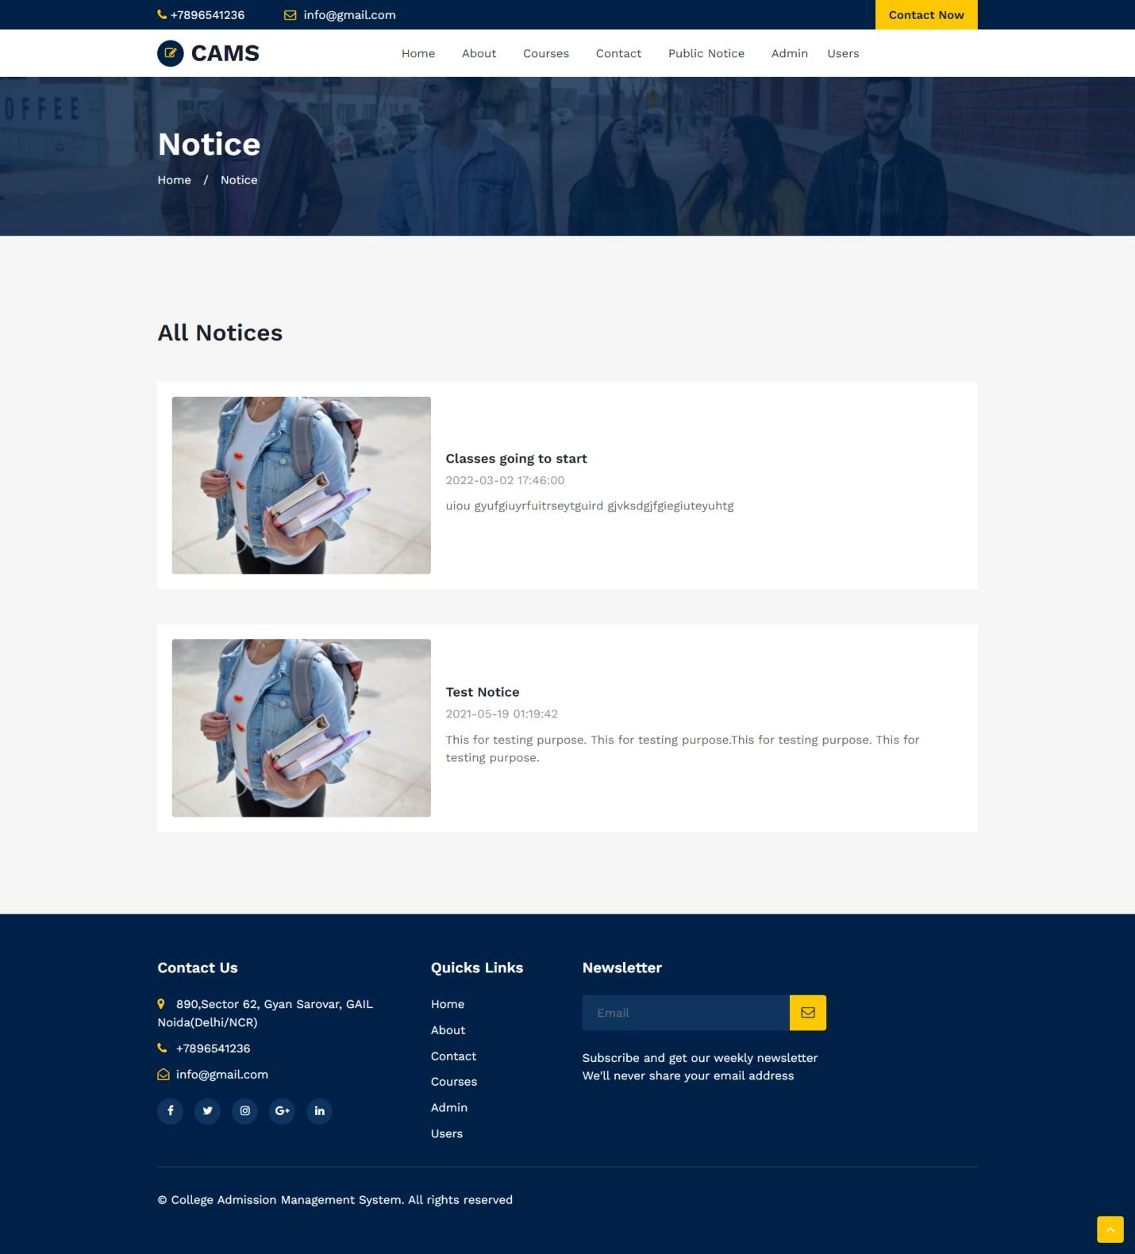

**Signup**

**Students Panel**

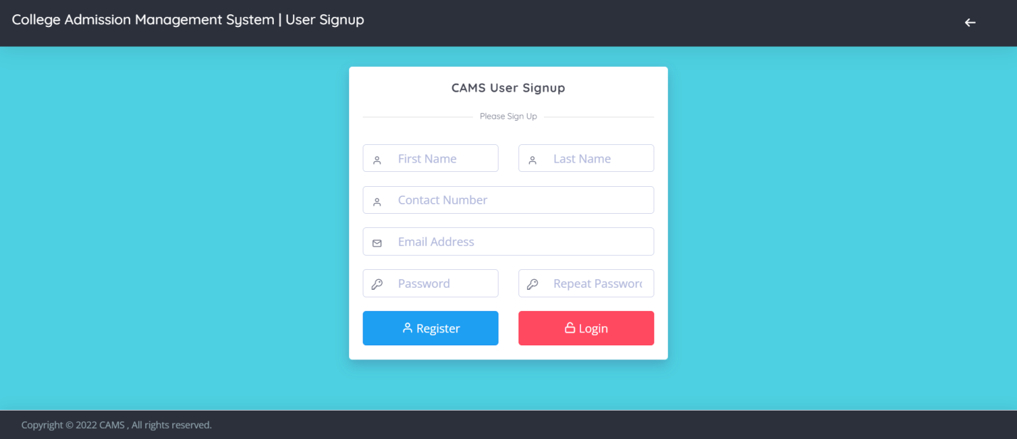

**Login Page**

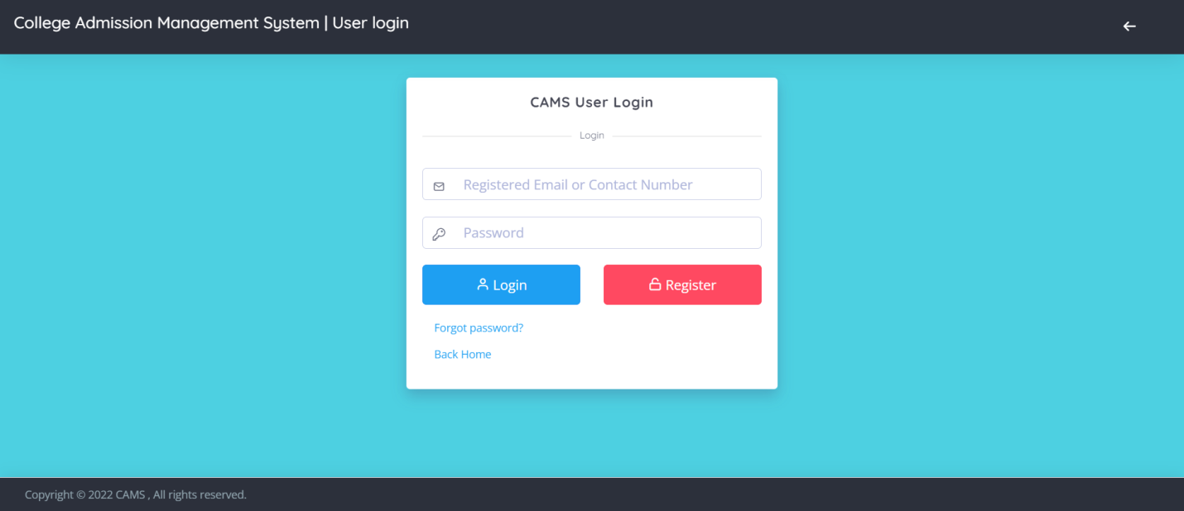

**Dashboard**

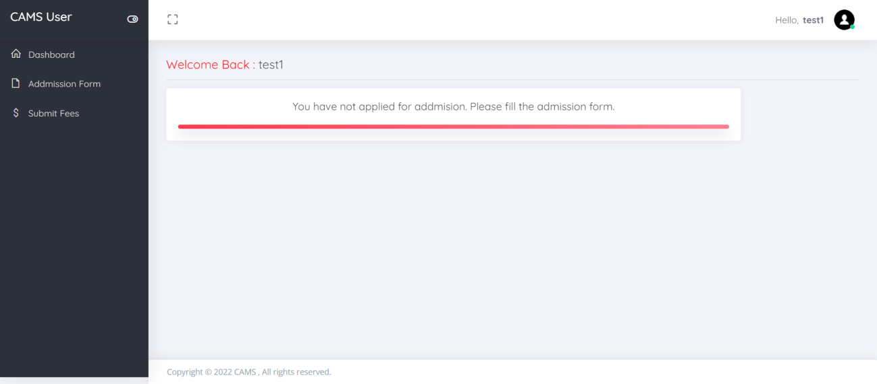

**Profile**

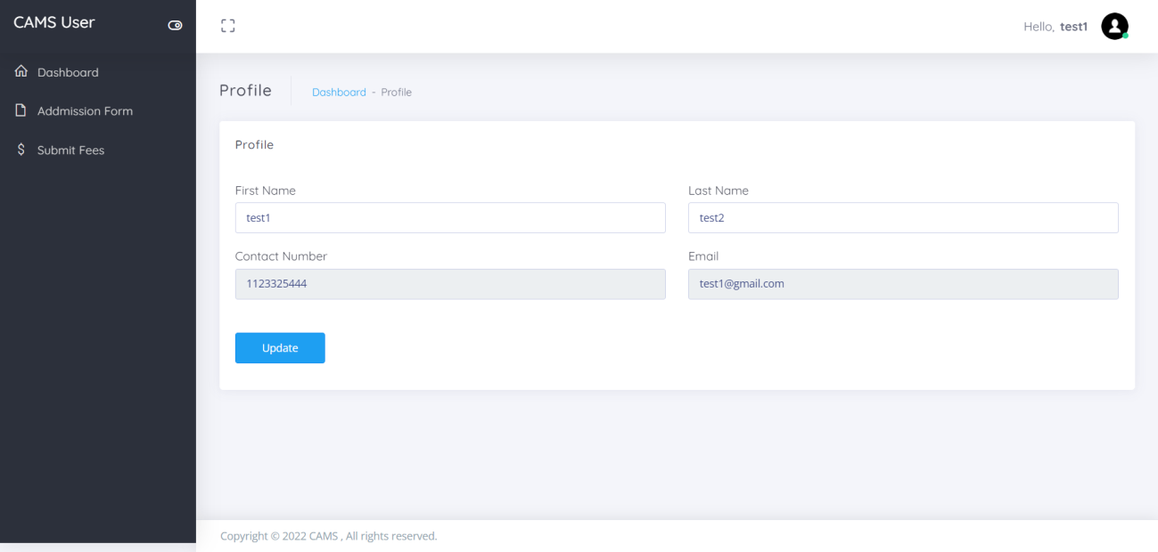

**Change Password**

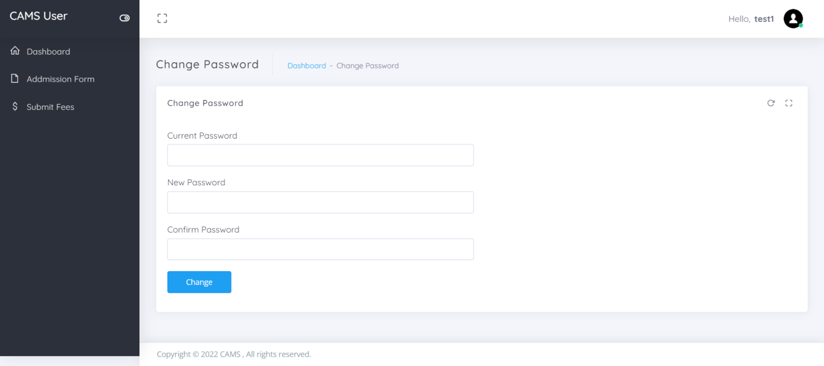

**Admission Form**

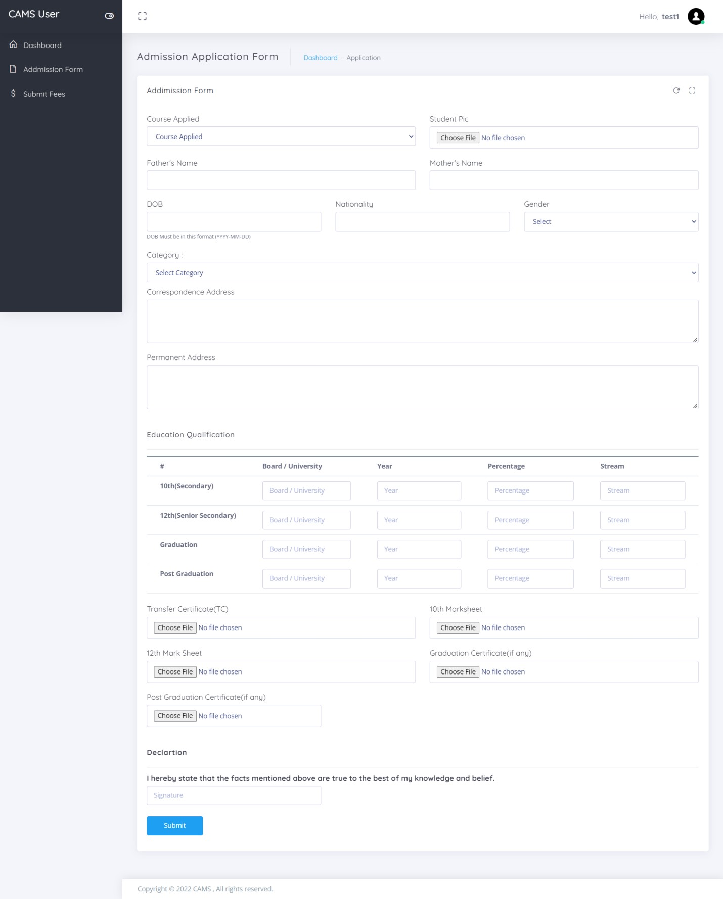

**Detail of Admission Form**

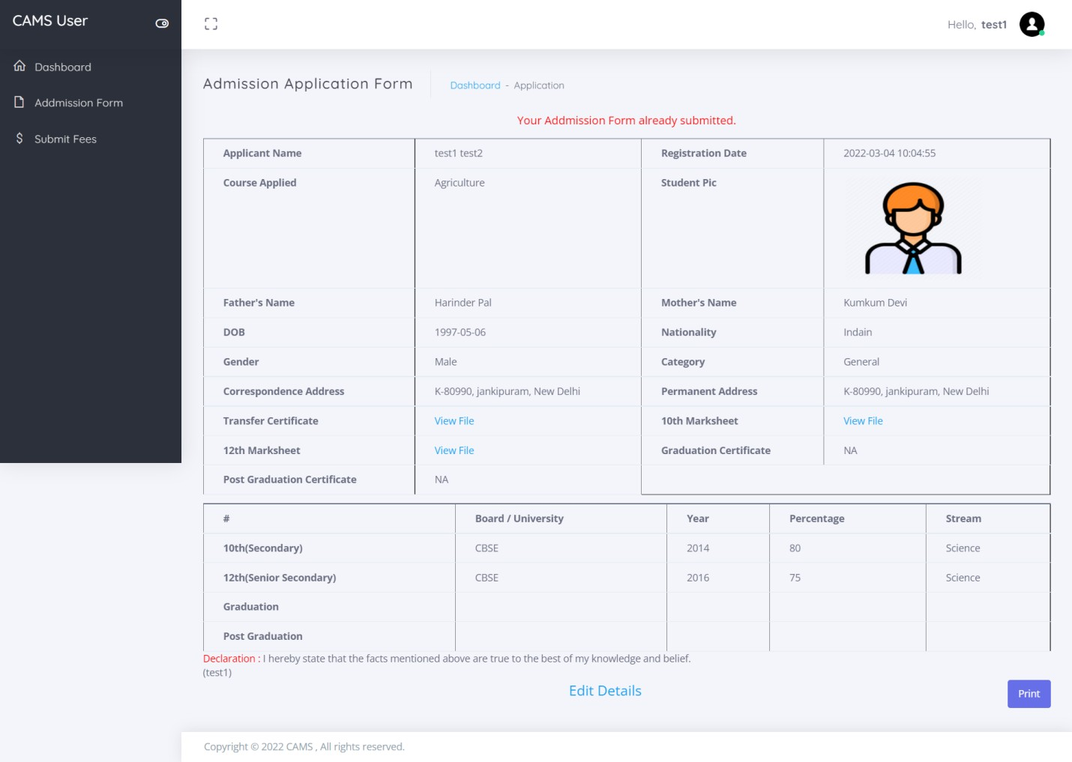

**Submit Fees**

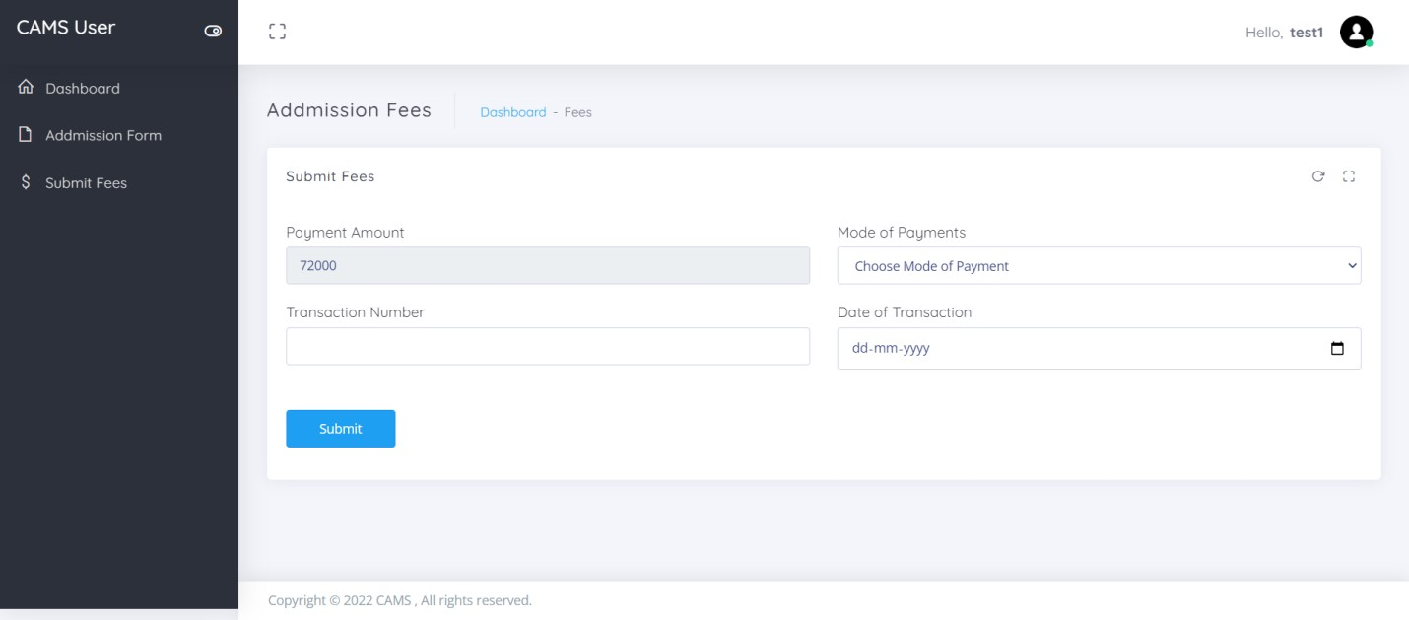

**Fees submission detail**

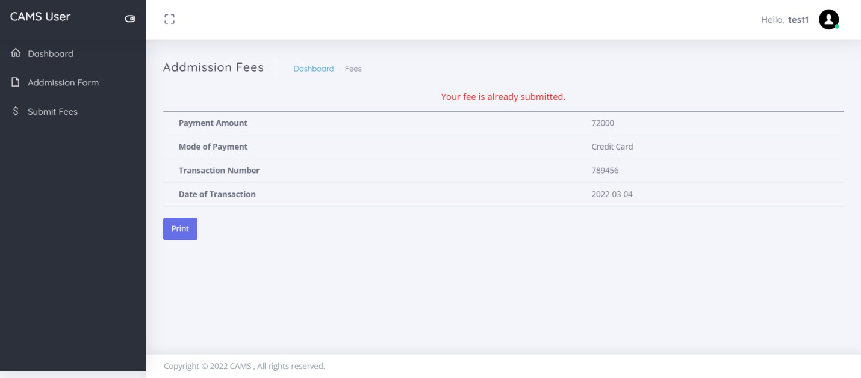

**Forgot Password**

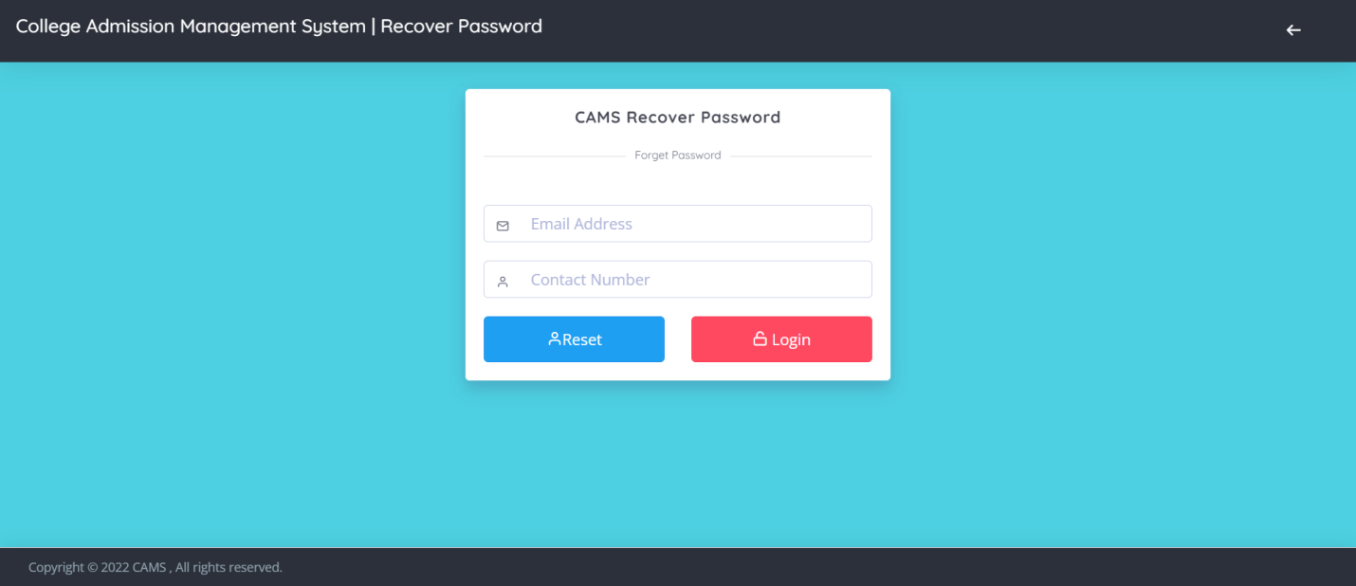

**Reset Password**

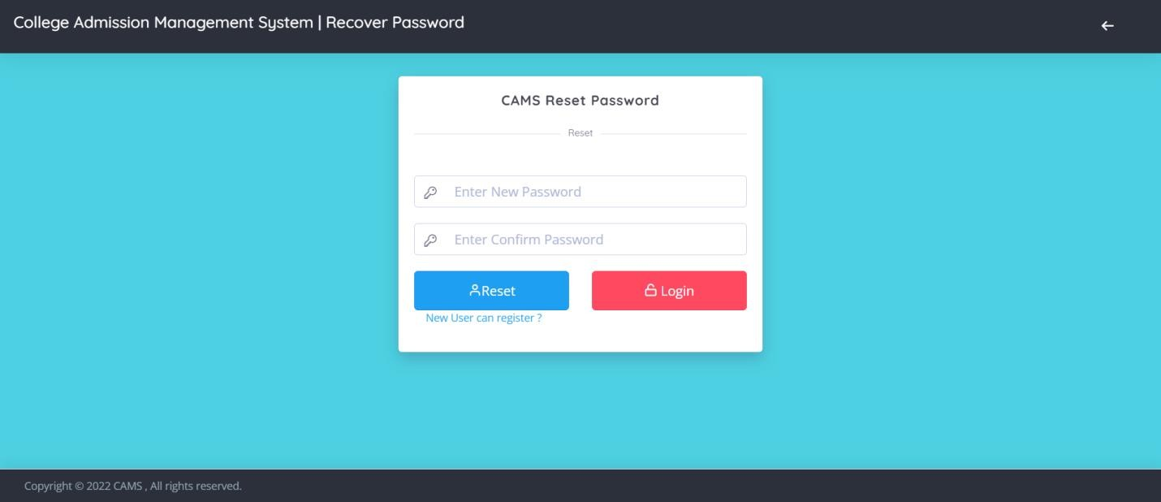

**Admin Panel**

**Login Page**

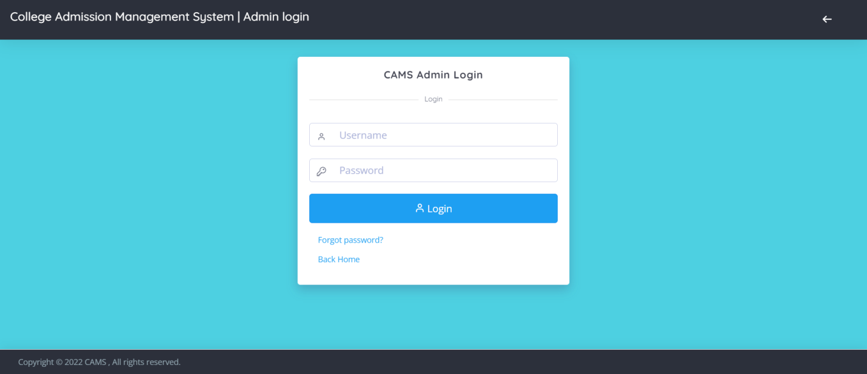

**Dashboard**

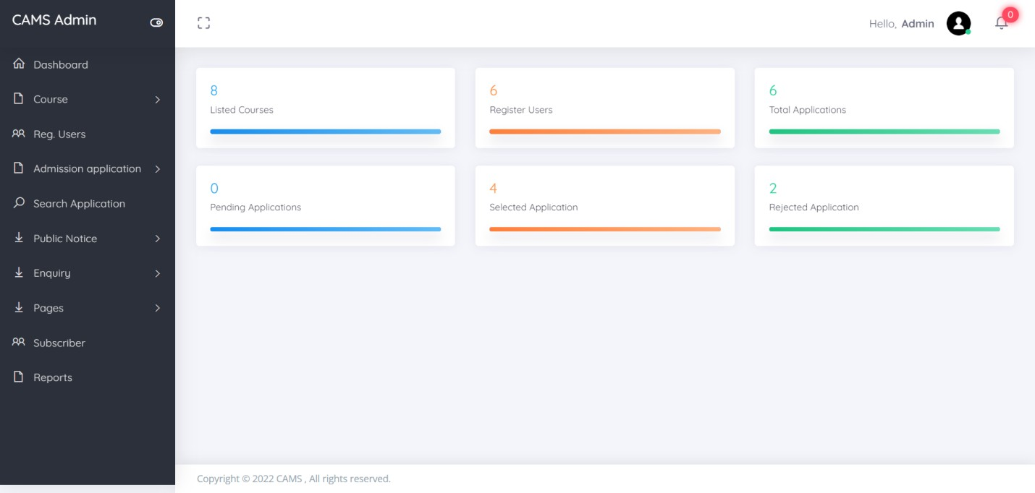

**Profile**

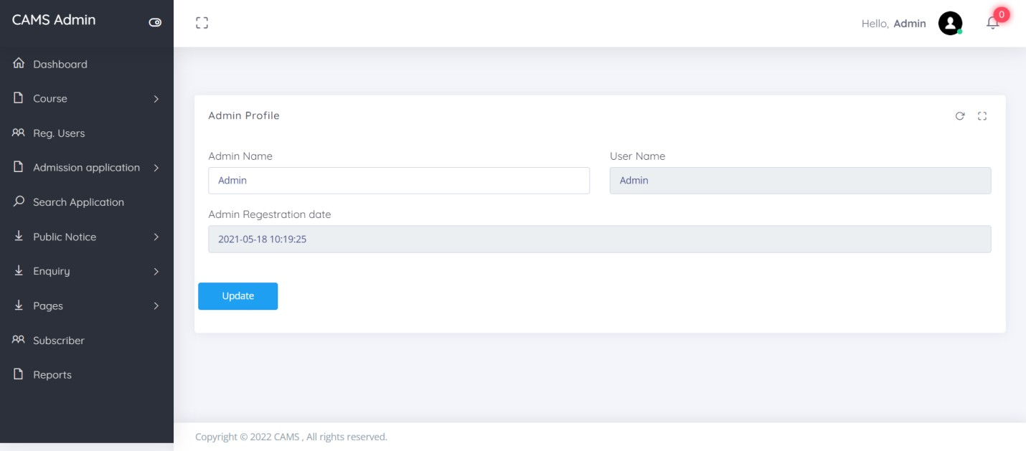

**Change Password**

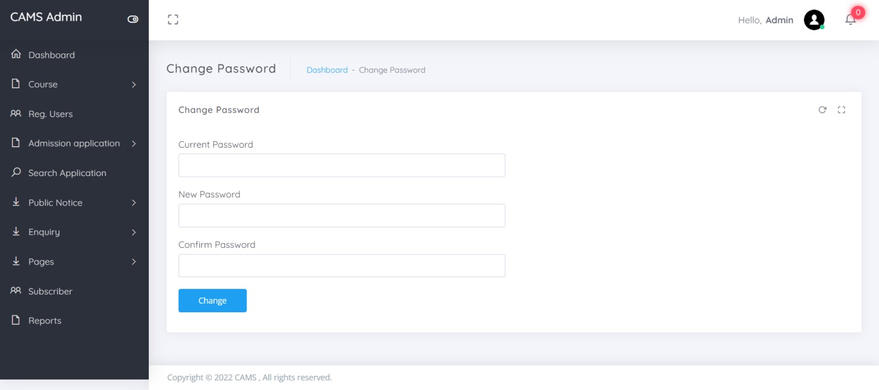

**Add Course**

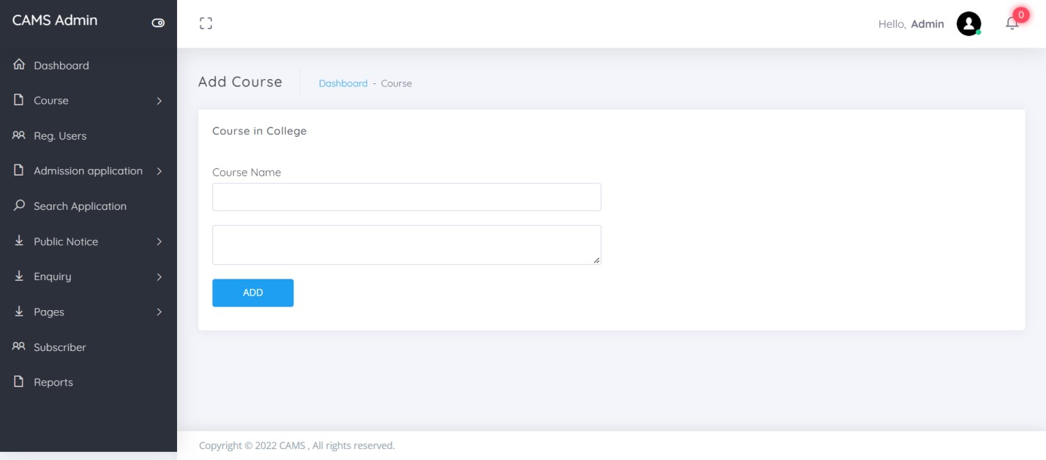

**Manage Course**

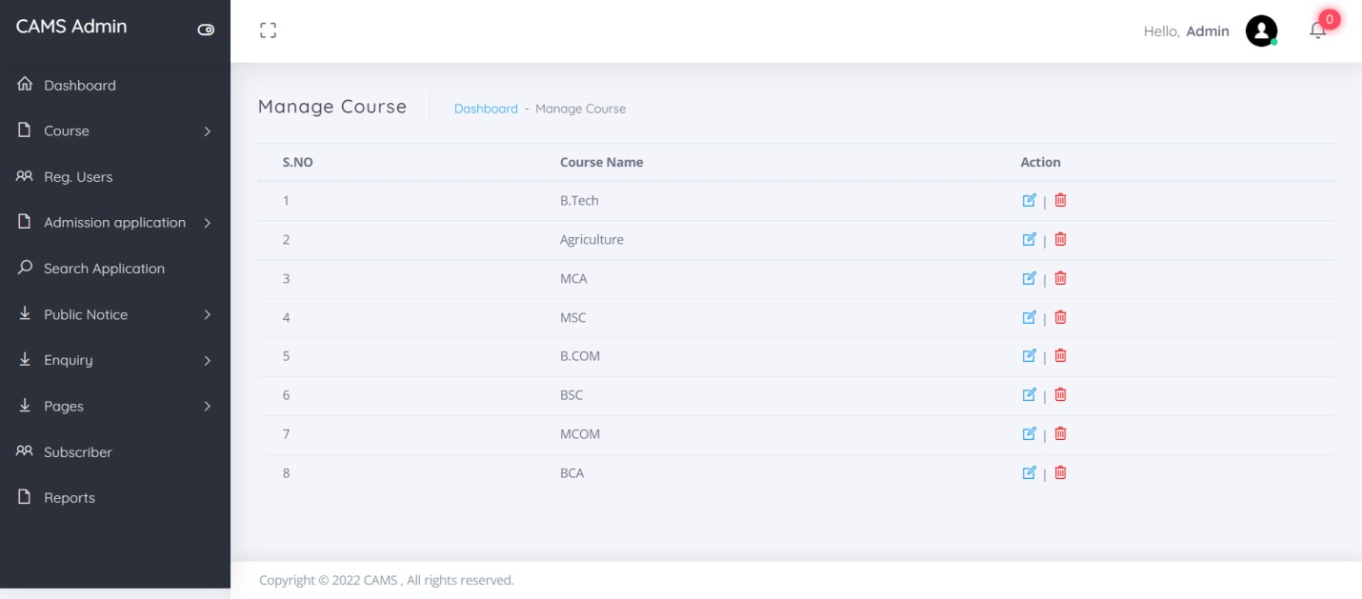

**Update Course**

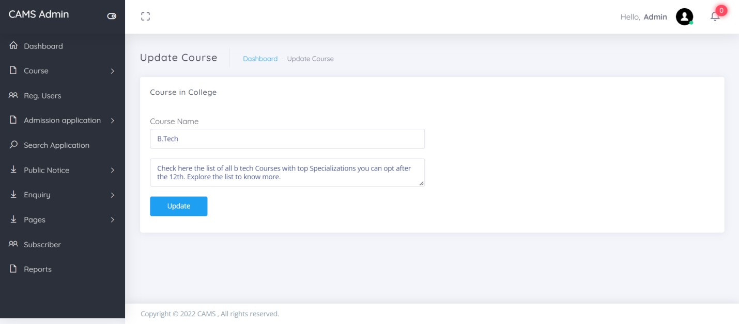

**Registered Users**

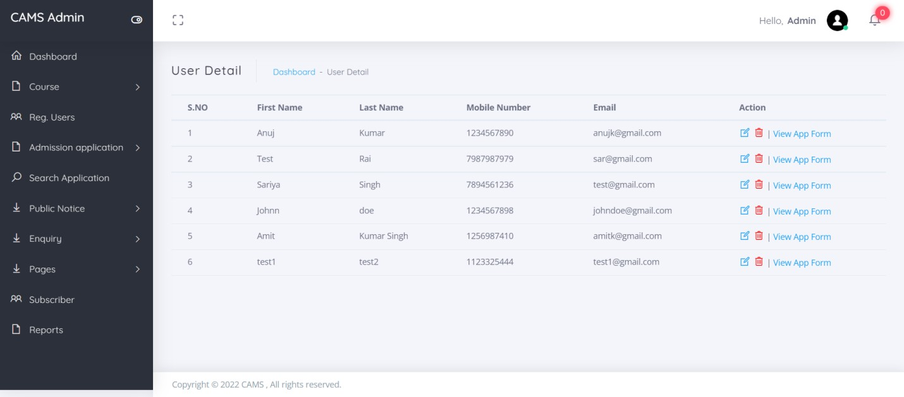

**Update Users Details**

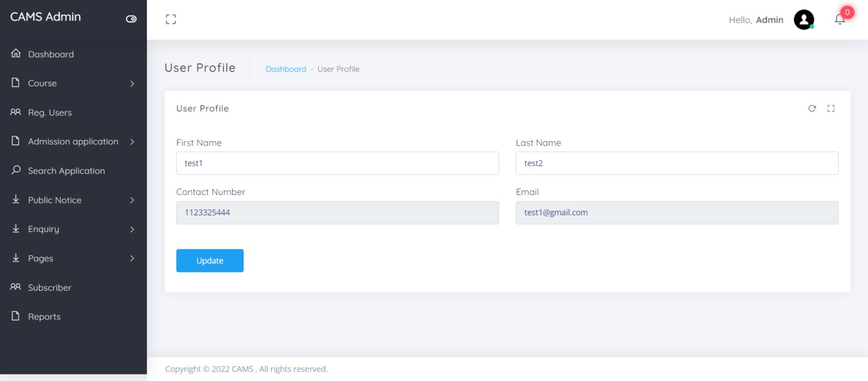

**View Application Form**

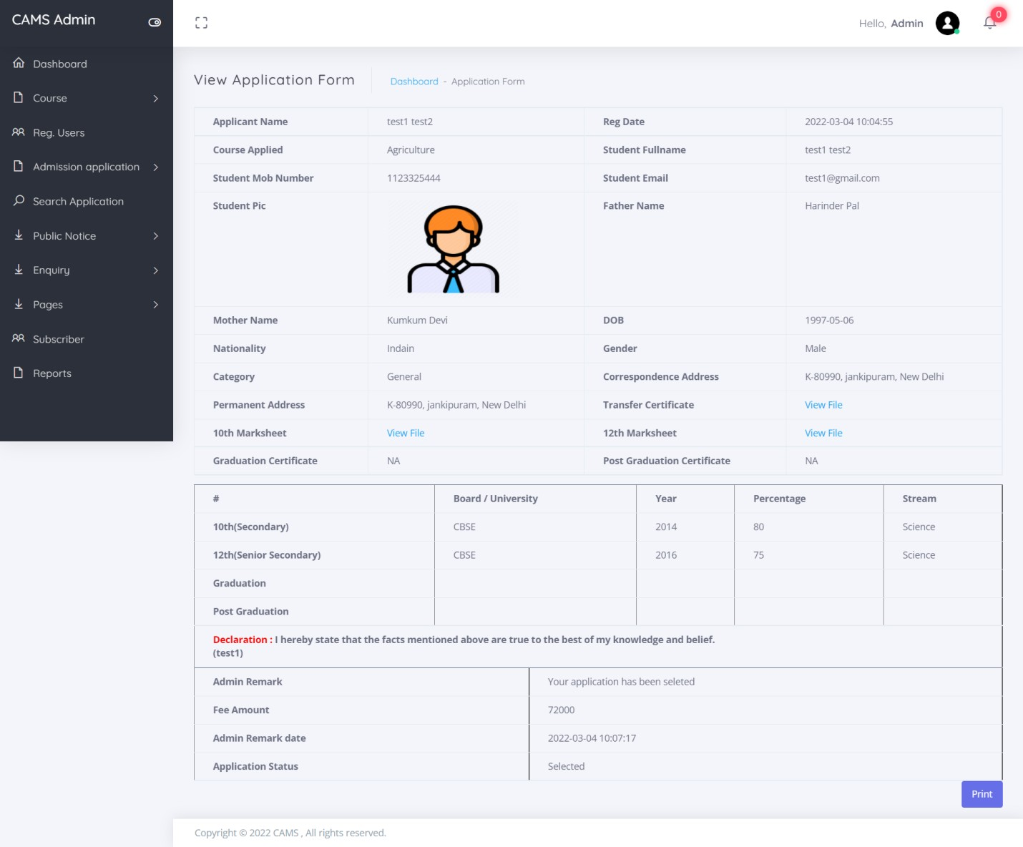

**Pending Application**

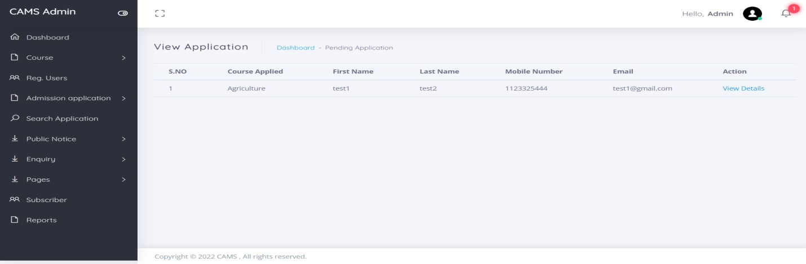

**View Pending Application**

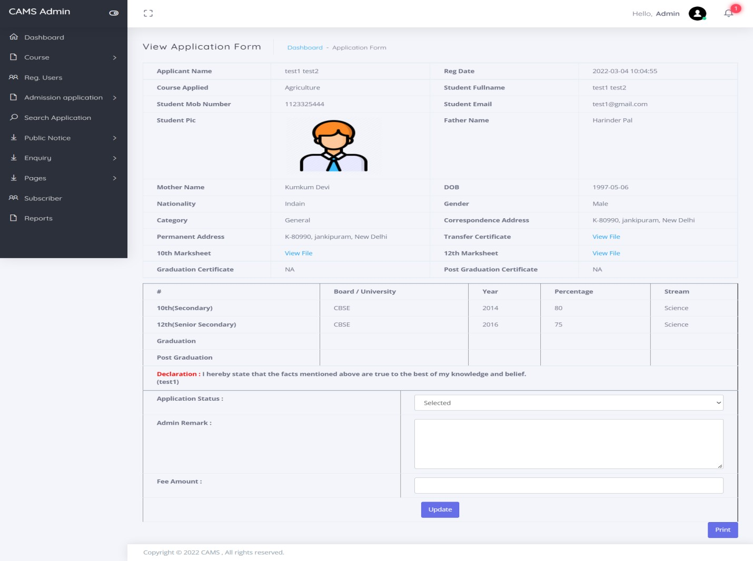

**Selected Application**

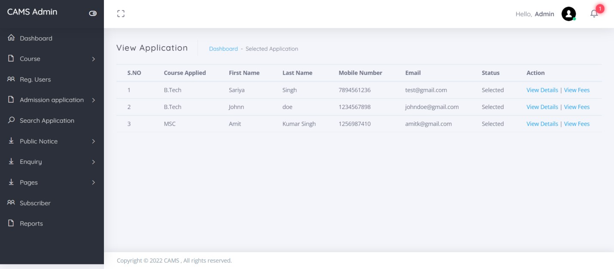

**View Selected Application**

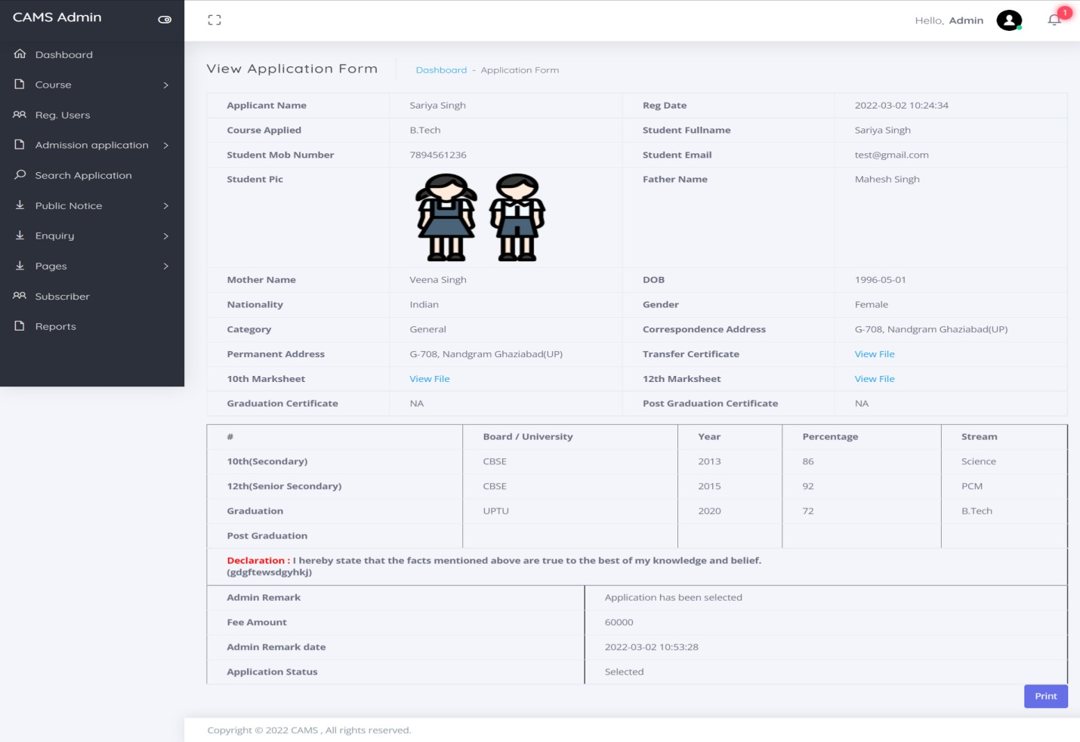

**Rejected Application**

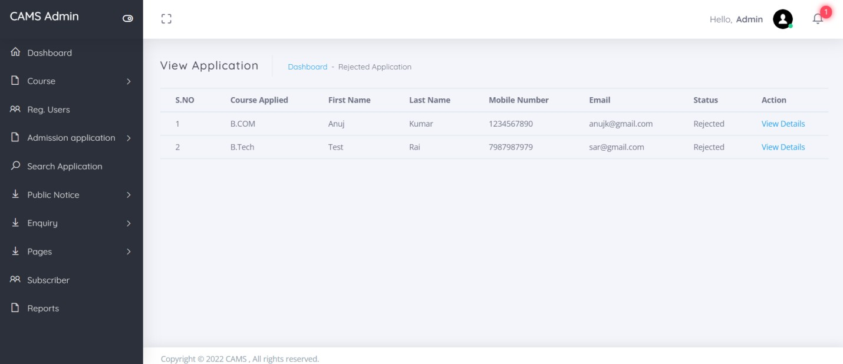

**View Rejected Application**

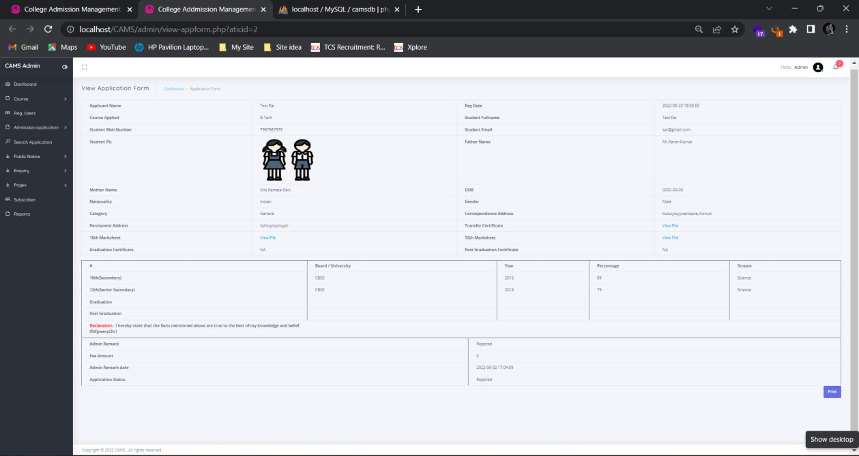

**All Application**

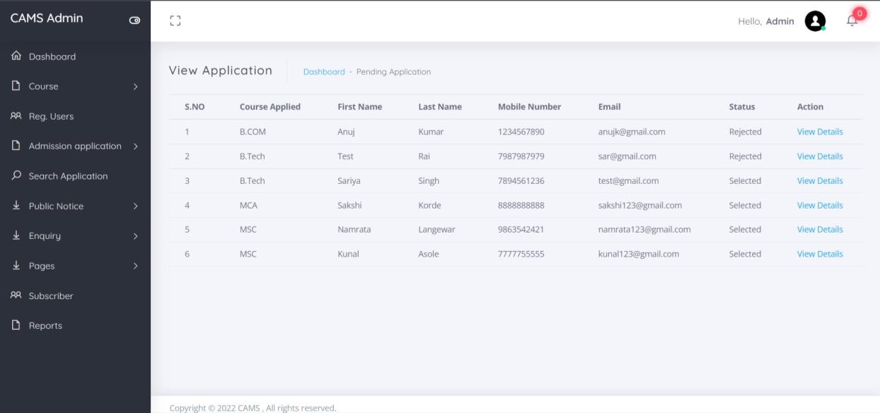

**Add Notice**

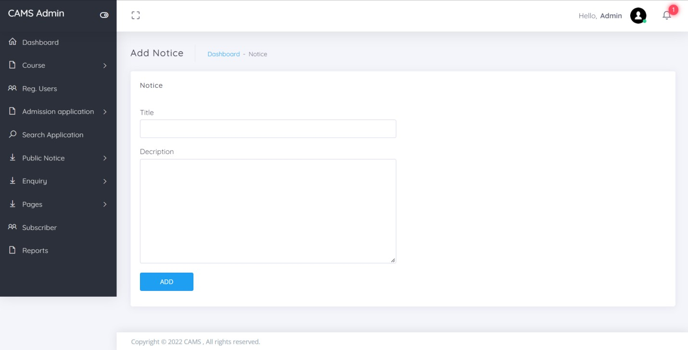

**Manage Notice**

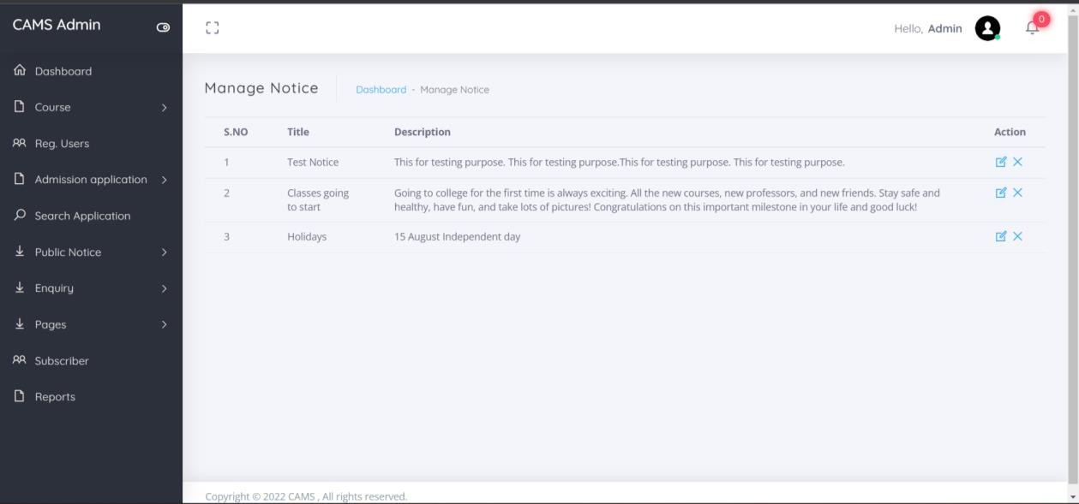

**Update Notice**

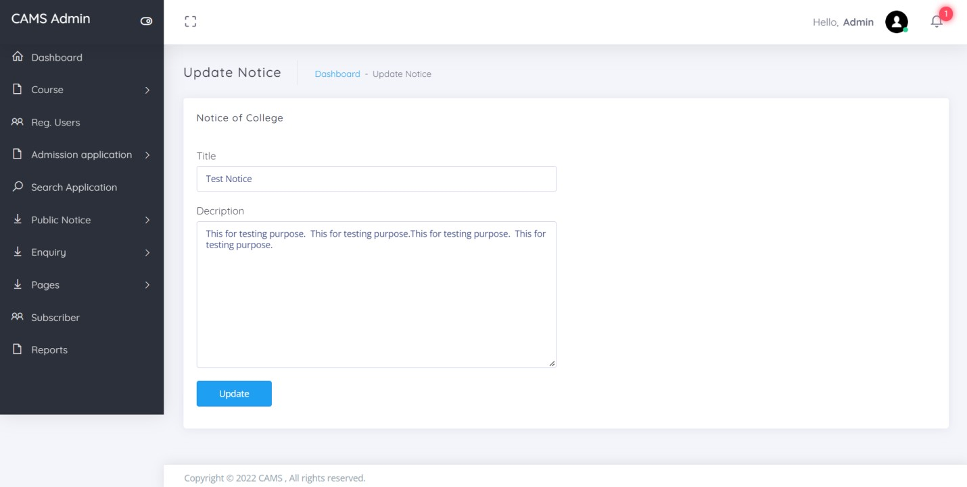

**Unread Enquiry**

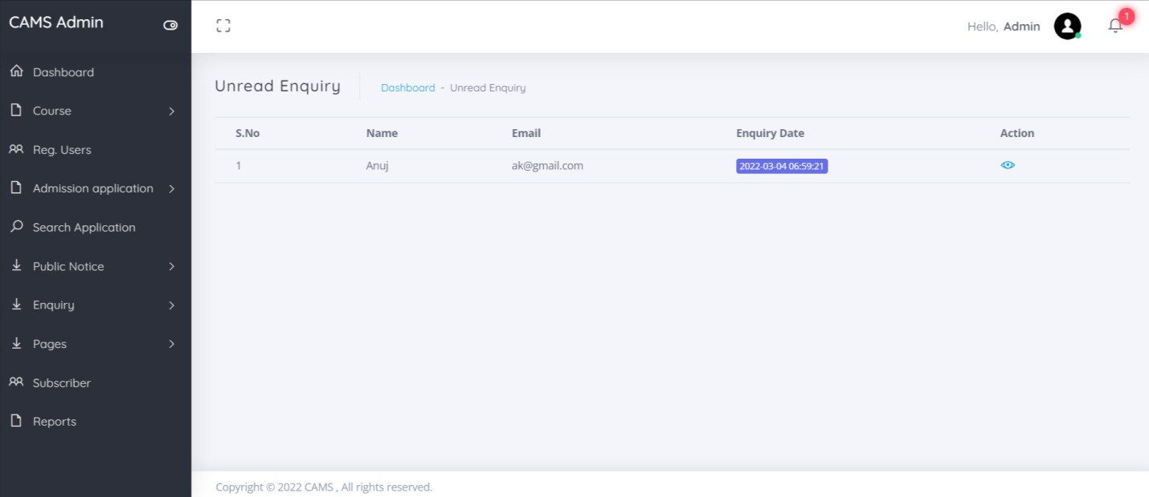

**View Unread Enquiry**

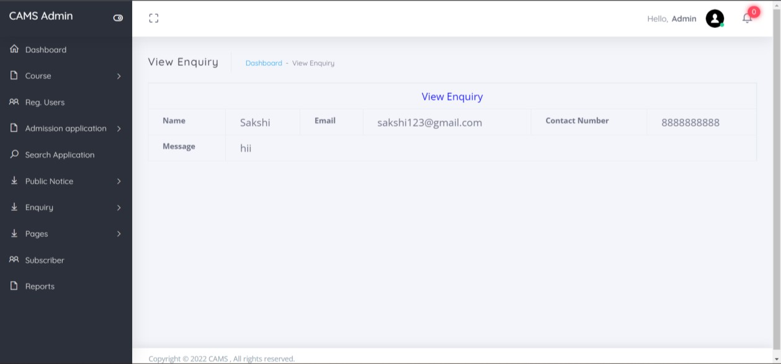

**About Us**

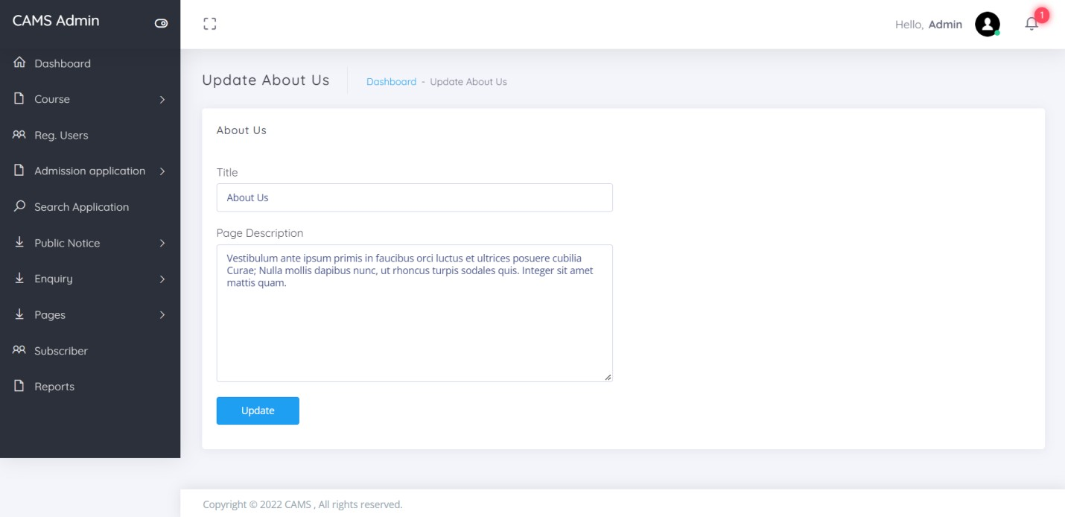

**Contact Us**

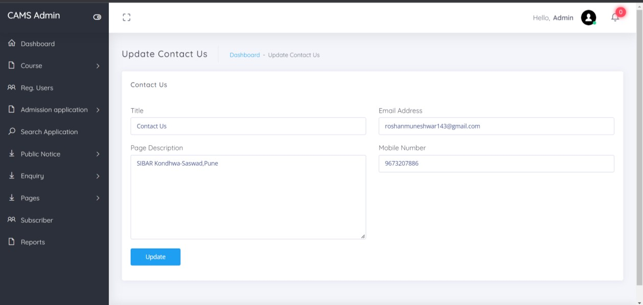

**Between Dates Report**

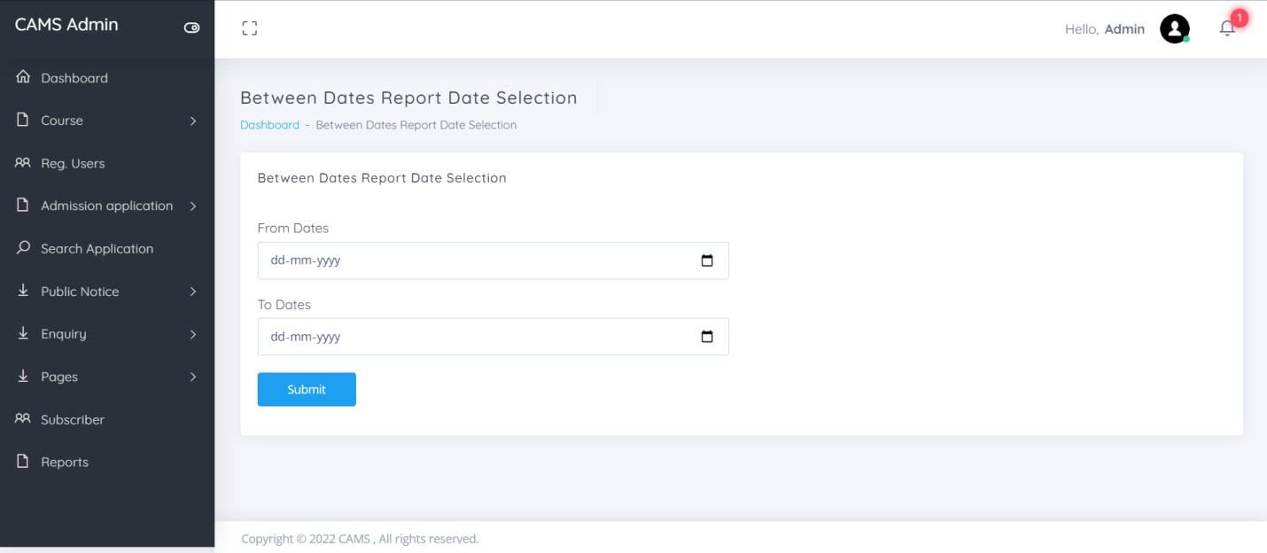

**View Between Dates Reports**

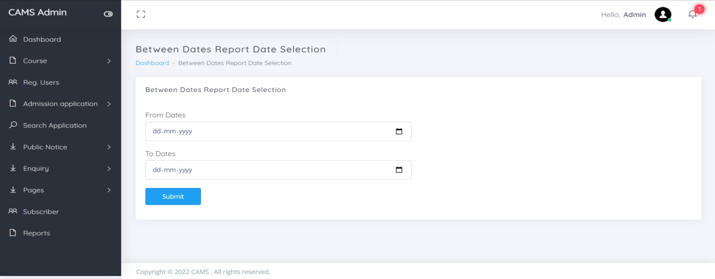

**Forgot Password**

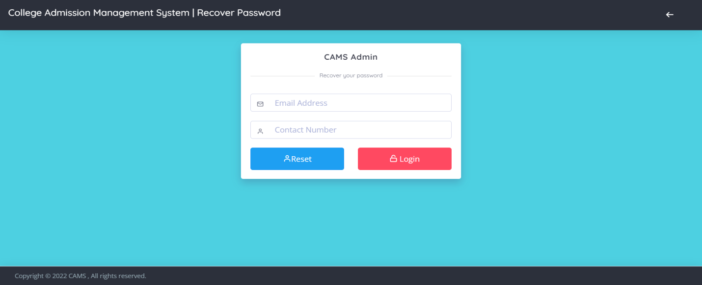

**Reset Password**

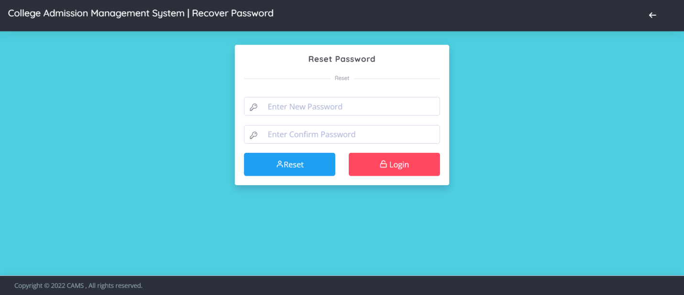

**SYSTEM TESTING**

System testing is the stage of implementation, which is aimed at ensuring that the system works accurately and efficiently before live operation commences. Testing is the process of executing the program with the intent of finding errors and missing operations and also a complete verification to determine whether the objectives are met and the user requirements are satisfied. The ultimate aim is quality assurance.

Tests are carried out and the results are compared with the expected document. In the case of erroneous results, debugging is done. Using detailed testing strategies a test plan is carried out on each module. The various tests performed in “**Network Backup System**” are unit testing, integration testing and user acceptance testing.

**Unit Testing**

The software units in a system are modules and routines that are assembled and integrated to perform a specific function. Unit testing focuses first on modules, independently of one another, to locate errors. This enables, to detect errors in coding and logic that are contained within each module. This testing includes entering data and ascertaining if the value matches to the type and size supported by java. The various controls are tested to ensure that each performs its action as required.

**Integration Testing**

Data can be lost across any interface, one module can have an adverse effect on another, sub functions when combined, may not produce the desired major

functions. Integration testing is a systematic testing to discover errors associated within the interface. The objective is to take unit tested modules and build a program structure. All the modules are combined and tested as a whole. Here the Server module and Client module options are integrated and tested. This testing provides the assurance that the application is well integrated functional unit with smooth transition of data.

**User Acceptance Testing**

User acceptance of a system is the key factor for the success of any system. The system under consideration is tested for user acceptance by constantly keeping in touch with the system users at time of developing and making changes whenever required.

# DESIGN AND IMPLEMENTATION CONSTRAINTS

Some of the design and implementation constraints identified are listed below:

* Student is not allowed to register with same email and contact number (Unique email and contact number will be registered).
* Student not has any rights to edit any data in the admission form after submission.
* Once admission application selected user can upload their docs once..
* This system is not support distributed database Facility.
* System is limited to HTTP/HTTPS Protocols.

Implementation is the stage in the project where the theoretical design is turned into a working system and is giving confidence on the new system for the users that it will work efficiently and effectively. It involves careful planning, investigation of the current system and its constraints on implementation, design of methods to achieve the change over, an evaluation of change over methods. Apart from planning major task of preparing the implementation are education and training of users. The implementation process begins with preparing a plan for the implementation of the system. According to this plan, the activities are to be carried out, discussions made regarding the equipment and resources and the additional equipment has to be acquired to implement the new system. In network backup system no additional resources are needed.

Implementation is the final and the most important phase. The most critical stage in achieving a successful new system is giving the users confidence that the new system will work and be effective. The system can be implemented only after thorough testing is done and if it is found to be working according to the specification. This method also offers the greatest security since the old system can take over if the errors are found or inability to handle certain type of transactions while using the new system.

**User Training**

After the system is implemented successfully, training of the user is one of the most important subtasks of the developer. For this purpose user manuals are prepared and handled over to the user to operate the developed system. Thus the users are trained to operate the developed system. Both the hardware and software securities are made to run the developed systems successfully in future. In order to put new application system into use, the following activities were taken care of:

* Preparation of user and system documentation
* Conducting user training with demo and hands on
* Test run for some period to ensure smooth switching over the system The users are trained to use the newly developed functions. User manuals

describing the procedures for using the functions listed on menu are circulated

to all the users. It is confirmed that the system is implemented up to users need and expectations.

**Security and Maintenance**

Maintenance involves the software industry captive, typing up system resources .It means restoring something to its original condition. Maintenance follows conversion to the extent that changes are necessary to maintain satisfactory operations relative to changes in the user’s environment. Maintenance often includes minor enhancements or corrections to problems that surface in the system’s operation. Maintenance is also done based on fixing the problems reported, changing the interface with other software or hardware enhancing the software. Any system developed should be secured and protected against possible hazards. Security measures are provided to prevent unauthorized access of the database at various levels. An uninterrupted power supply should be so that the power failure or voltage fluctuations will not erase the data in the files.

Password protection and simple procedures to prevent the unauthorized access are provided to the users .The system allows the user to enter the system only through proper user name and password.

# SUPPLEMENTARY REQUIREMENTS

**Reduce the Cost of Admission Process**: The main aim of the System is to reduce the cost needed for Admission Process, so it automatically reduces the manual power needed to perform the entire task and improve the quality of the work.

**Increase the Quality of the Process**: The System facilitates the work of the universities and the same time it must reduce the work load of the organization with expected quality. Quality in the sense, the system try to avoid the mistakes that are usually happen during the Admission Process because names of the students sometimes missed in the selected list and call letters for the students also not send properly to the qualified students. Make the Interface Simple as Possible.

**Reduced Time**: To perform any task time is one of the important factors to consider. If the system not utilize properly time, than the entire aim of system is fails and the sys tem is fails to reach its goal. So time take to process all these activities should be less but the output should be effective.

# OTHER NONFUNCTIONAL REQUIREMENTS

**Performance Requirements**

Some Performance requirements identified is listed below:

* The database shall be able to accommodate a minimum of 1000,000 records of Students.
* The software shall support use of multiple users at a time.
* There are no other specific performance requirements that will affect development.

**Security Requirements**

Some of the factors that are identified to protect the software from accidental or malicious access, use, modification, destruction, or disclosure are described below. Specific requirements in this area could include the need to:

* Utilize certain cryptographic techniques
* Keep specific log or history data sets
* Assign certain functions to different modules
* Restrict communications between some areas of the program
* Check data integrity for critical variables
* Later version of the software will incorporate encryption techniques in the user/license authentication process

**Portability Requirements**

Some of the attributes of software that relate to the ease of porting the software to other host machines and/or operating systems. This may include:

Java is used to develop the product. So it is easiest to port the software in any environment.

**Maintainability**

The user will be able to reset all options and all stored user variables to default settings.

#### Reliability

Some of the attributes identified for the reliability is listed below:

All data storage for user variables will be committed to the database at the time of entry.

Data corruption is prevented by applying the possible backup procedures and techniques.

#### Usability requirements

Some of the usability requirements identified for this system are listed below: o A logical interface is essential to an easy to use system, speeding up

common tasks.

* Error prevention is integral to the system and is provided in a number of formats from sanity checks to limiting free-text input.

# CONCLUSION

In this way we are going to develop college admission system, which is helpful for Reduction in manual work so less manpower required. Students’ records can be accessed within few seconds, Clarity in account section. Our system primarily focuses on building an efficient and user friendly communication system for the educational institutions.

# REFERENCE

##### PHP.net.

* + ***Sitepoint*.com**
  + ***W3School*.com**

##### Google web search

* + ***Wikipedia***